Mat. Requests Processing
Facilities Information Management Administration (FIMA) system has two panels required for entering material requests. The below listed titles are the Mat. Requests Processing panels. This document explains the following FIMA steps necessary to accomplish these processes:
- Starting FIMA (pg 2)
- Entering Material Requests (pg 3) (Inventory Orders)
- Entering Material Requests (pg 14) (Vendor Orders)
- Special Instructions (pg19)
- Unit of Issue Table (pg 20)
To perform these tasks, you will be using the mouse to select and open applications and folders and to make selections within applications. The following terms for using the mouse are used throughout these instructions:
When you see this… | Do the following…
Click | Click the left mouse button once. This will select an application icon or a folder.
Right-Click | Click the right mouse button once. This will open a menu of options for a selected application icon or folder.
Double-Click | Click twice rapidly with the left mouse button. This will open a folder or start an application.
Scroll | Roll the scroll wheel forward or backwards depending on the direction required on the document. Forward = UP, Backwards = DOWN

(See Glossary of Terms for all descriptions of information entered)
Starting FIMA
On the desktop screen double click on this icon 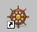 The following screen will appear.
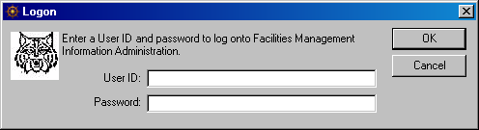
Enter your User ID: and Password: and click OK or press the enter key.
FIMA is now open, on the top left of the screen there are numerous icons.
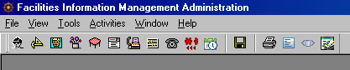
Different icons appear for each individual and shops. The icons are based on your authorization level.
A material request can now be entered. Follow the steps below for entering material requests for stock and non-stock items.

Top of the Document

Entering Material Request (Inventory Orders)
After opening FIMA, click on the Material Request button. The following screen appears with this set of tabs:
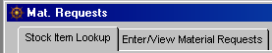
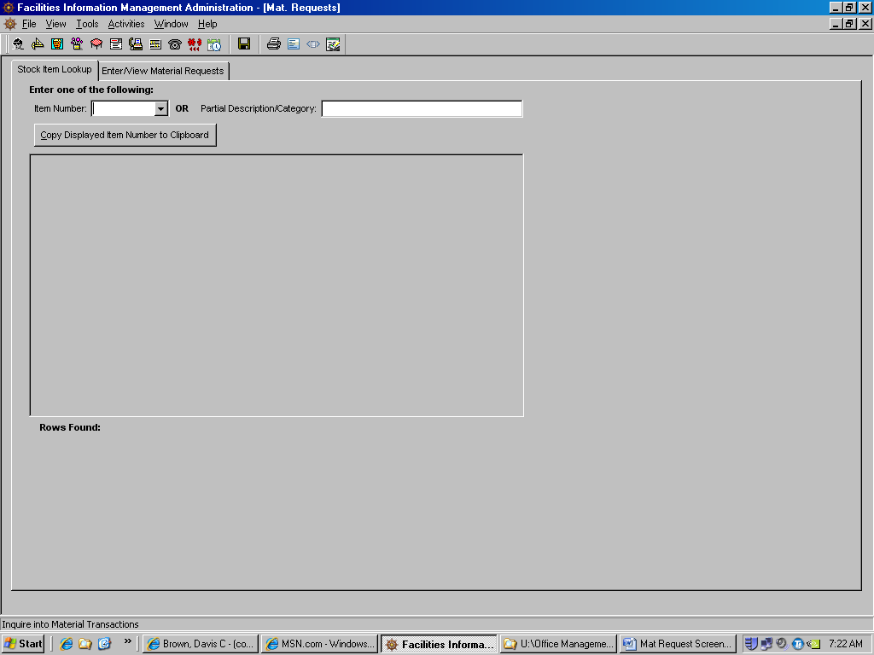
Click on Enter/View Material Request. This screen appears.

Top of the Document
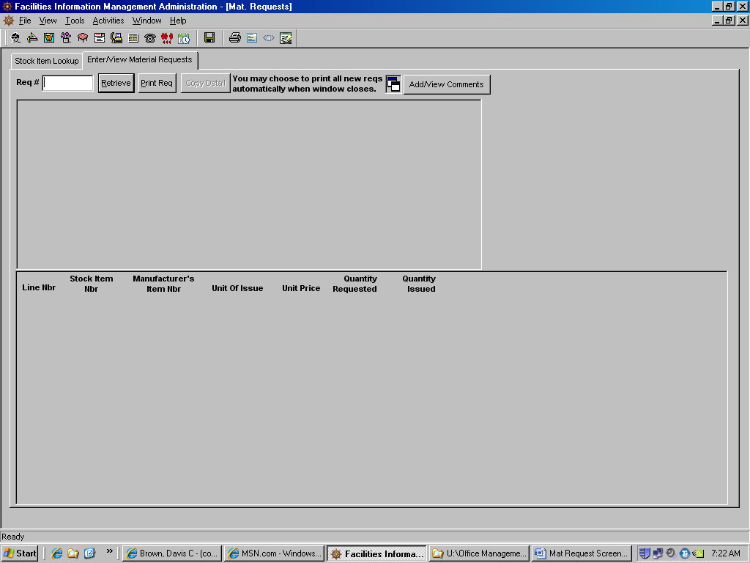
This screen is used for entering all material requests. There are two (2) types of material requests; inventory orders and vendor orders for non-stock items.
NOTE: Before entering a material request, contact the Work Control Desk for a service request number.
To enter a new request Right click anywhere on the screen.
The following box appears, click on Add and the following screen appears.
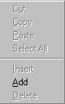

Top of the Document
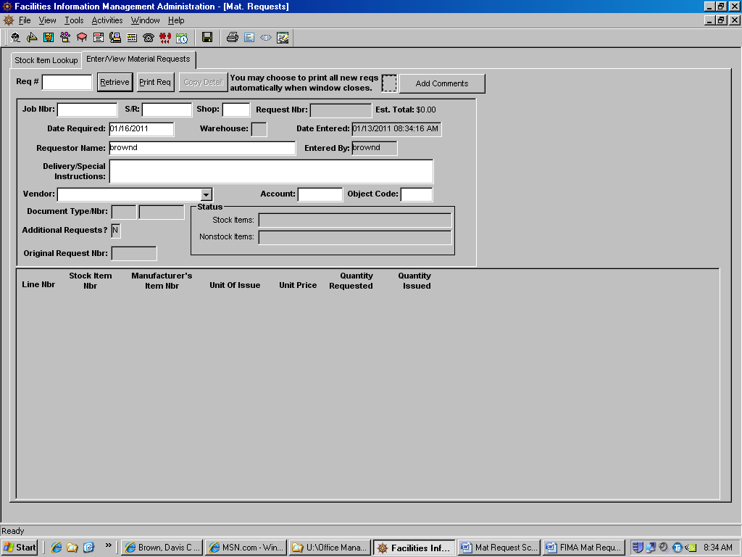
Enter the following information in their respective boxes. Boxes that are grayed out cannot be changed.
Job Nbr: Job Number
S/R: Service Request Number
Shop: Self Explanatory
As the above information is entered the account number will appear in that block.
Date Required: and Requestor Name: are filled in automatically. However, these can be changed. For instance if this request is an urgent order, then click in the Requestor Name block and add /Urgent after the name.
Warehouse: If known enter the warehouse number. The material control warehouse number is 1.
Delivery/Special Instructions: Enter any misc. information in this block. For example: building numbers, where to deliver materials, if parts will be picked up (Will Call) etc.
Vendor: Leave this block blank for inventory items.
Account: and Object Code: Leave blank or as is.

Top of the Document
Next select the item numbers for this request. Right click in the grayed area on the bottom of the screen.
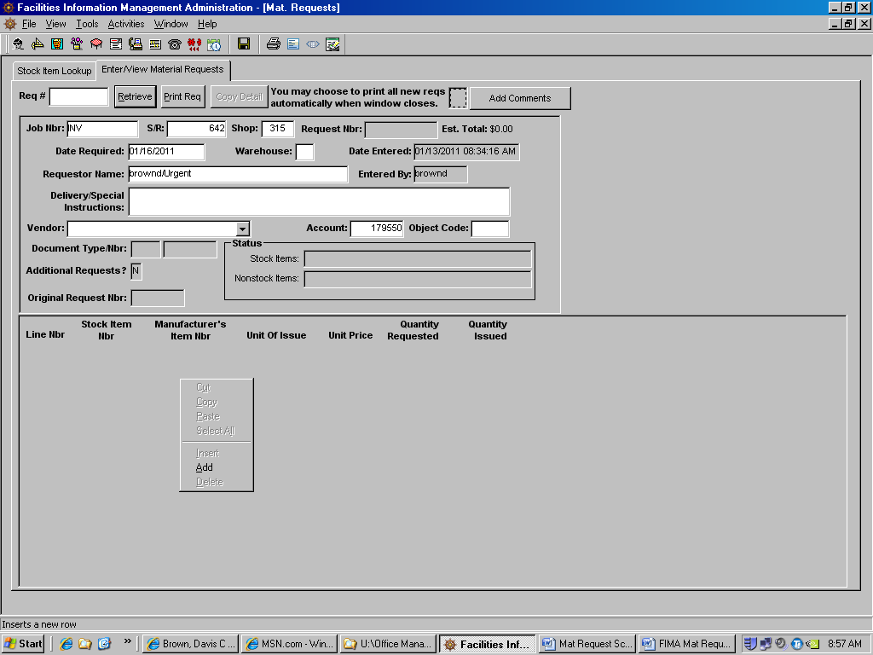
This following box appears, click on Add and the following screen appears.

Top of the Document
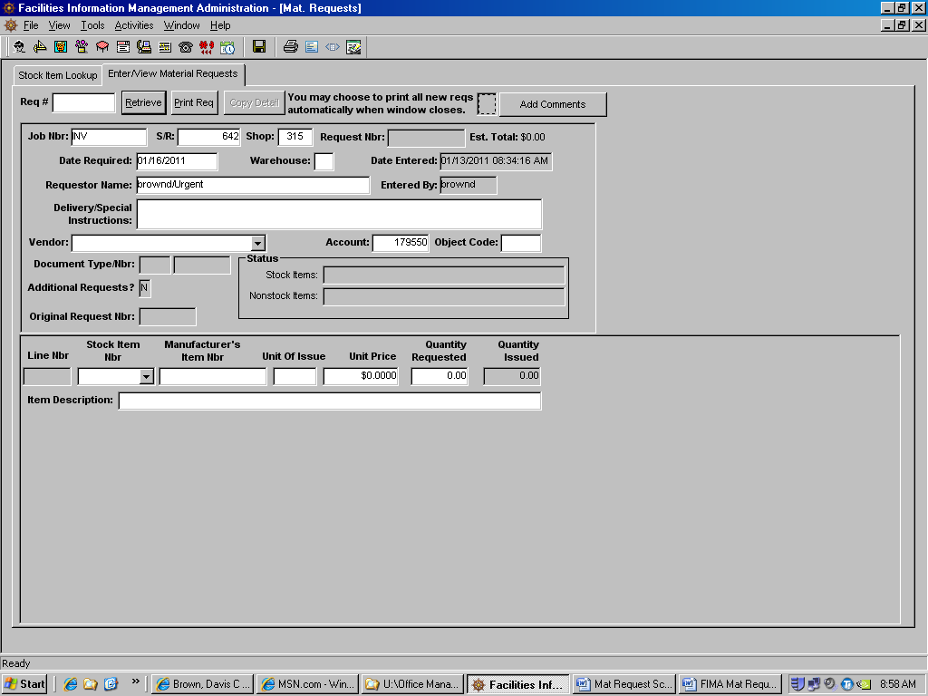
Drop Down Arrow
There are three ways to enter the item numbers for this material request.
- Type in the item number if known
- Click on the Drop Down Arrow and a list of all active item numbers will appear as follows:
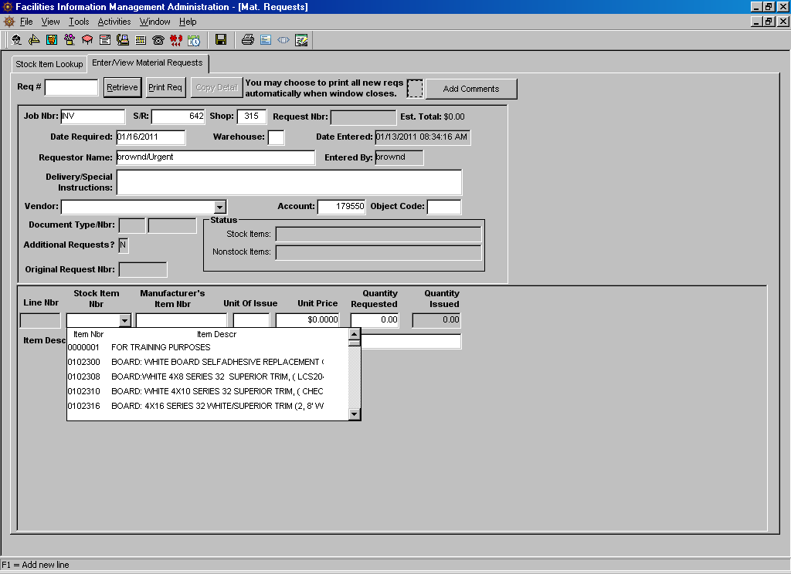
Arrow down until the item required appears and then click on that item.
- The third options is to use the Stock Item Lookup tab.
Click on the Stock Item Lookup tab, the following screen appears.
Drop Down Arrow
Click on the Drop Down Arrow and a list of all active item numbers appear as appears below.

Top of the Document

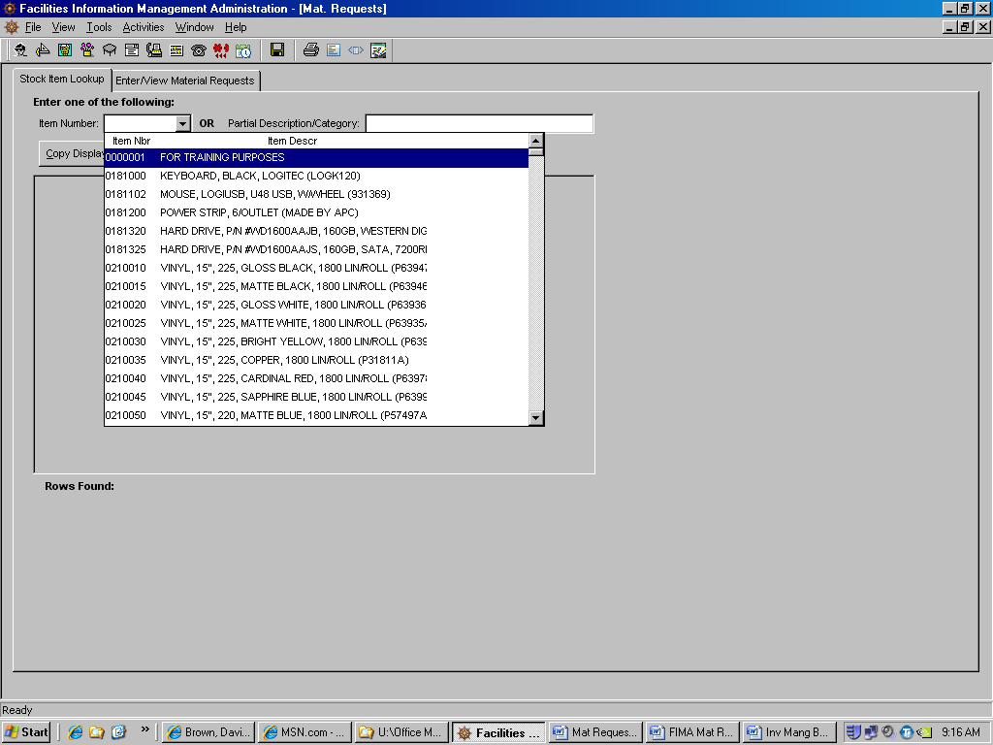
Arrow down to the required item number and click on that item.
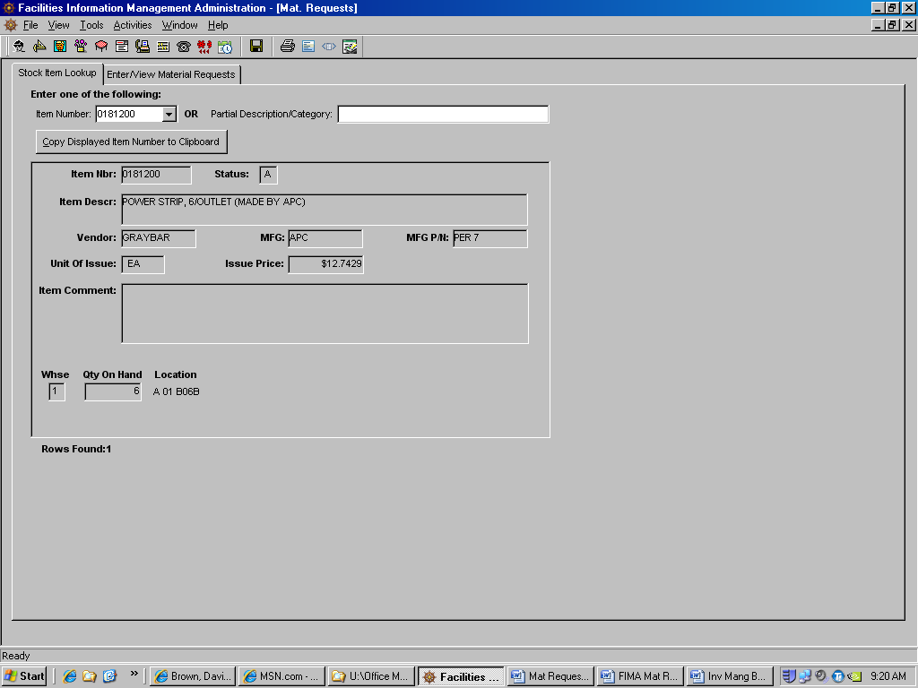
The information for that item is displayed as follows:
Item Nbr:
Status: A = Active
Item Descr: If the vendor’s part number is different from the manufacturer’s that number will appear after the description within parentheses ( ).
Vendor: Vendor this item is purchased from.
MFG: Manufacturer of this part.
MFG P/N: Manufacturer’s part number.
Unit of Issue:
Issue Price:
Item Comment:
Whse: Warehouse number.
Qty on Hand: Quantity on hand at the warehouse.
Location: Warehouse location.
To transfer this information to the order being enter click on the Copy Displayed Item Number to Clipboard button.
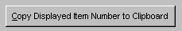
Next click on the Enter/View Material Requests tab.
When the order screen appears, Right click in the space under Stock Item Nbr and select Paste.

Top of the Document
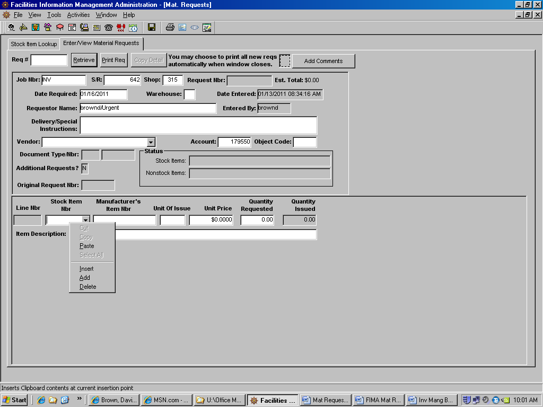
The item number now appears in this block. Press the Tab key on the keyboard.
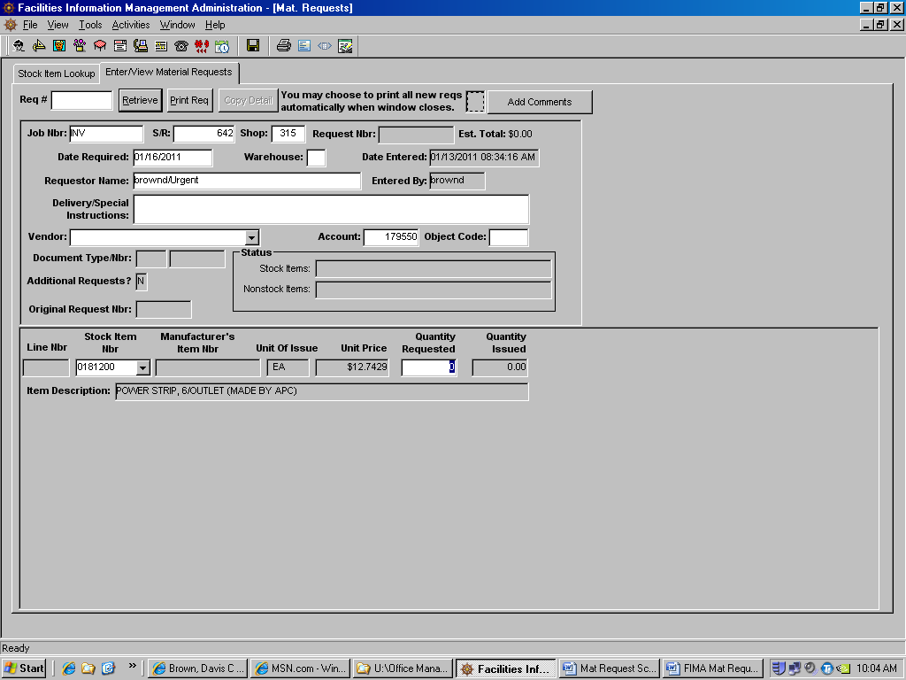
The Unit of Issue, Unit Price and Item Description are now added.
Enter the Quantity Requested.
Add as many items as are require for this material request.
There is one more way to find items on the Stock Item Lookup panel. Enter a keyword in to the block labeled Partial Description/Category and press Enter key.
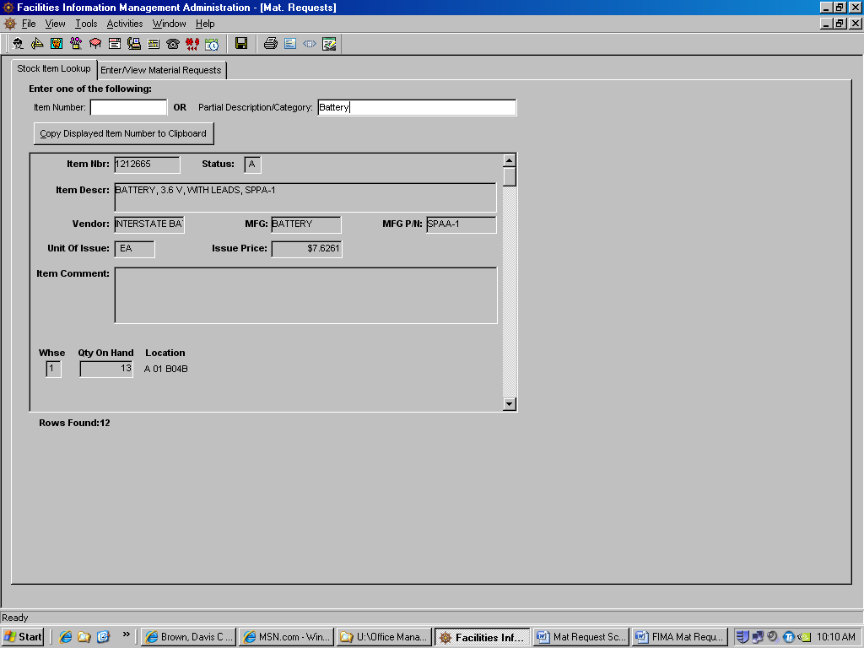
Range of items with this keyword
All items with this keyword appear in a list, arrow down or up to find the required item. Then follow the steps to Copy Displayed Item Number to Clipboard.
Once all items are enter into the material request click on the save button.
The material request number is now assigned to this order. At this time the material request can be printed. To print, click on the Print Req button.

Top of the Document
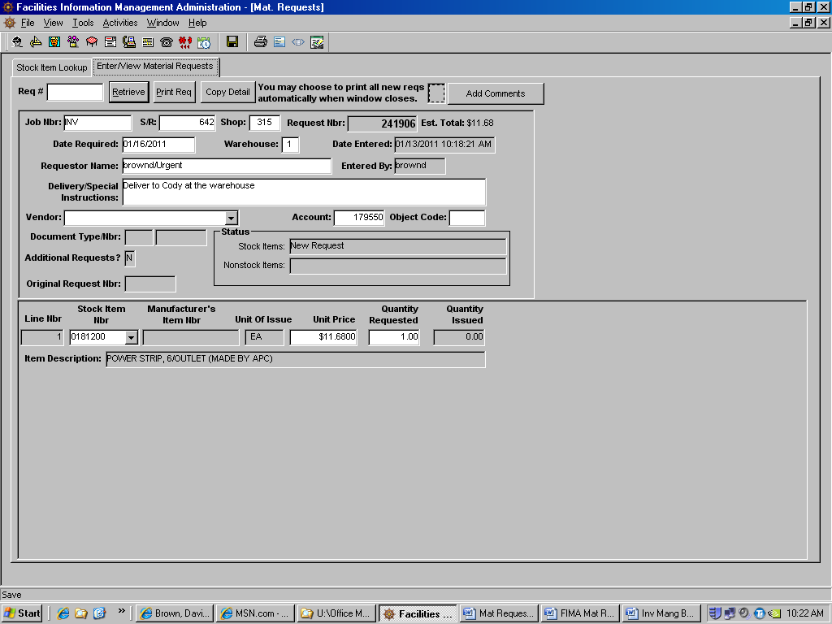
Material request number
Print Req Button
The second type Material Request is for non-stock materials placed with vendors.

Top of the Document
Entering Material Request (Vendor Orders)
After opening FIMA, click on the Material Request button. The following screen appears with this set of tabs:
Click on Enter/View Material Request. This screen appears.
This screen is used for entering all material requests. There are two (2) types of material requests; inventory orders and vendor orders for non-stock items.
NOTE: Before entering a material request, contact the Work Control Desk for a service request number.
To enter a new request Right click anywhere on the screen.
The following box appears, click on Add and the following screen appears.

Top of the Document
Enter the following information in their respective boxes. Boxes that are grayed out cannot be changed.
Job Nbr: Job Number
S/R: Service Request Number
Shop: Self Explanatory
As the above information is entered the account number will appear in that block.
Date Required: and Requestor Name: are filled in automatically. However, these can be changed. For instance if this is request is an urgent order, then click in the Requestor Name block and add /Urgent after the name.
Warehouse: Leave this block blank
Delivery/Special Instructions: Enter any misc. information in this block. For example: building numbers, where to deliver materials, if parts will be picked up (Will Call) etc.
NOTE: If a quote has been issued this area should contain that quote number and the individual’s name who provided the quote.
Vendor: Select the vendor for this material request by clicking on the down arrow. A list of all active vendors will appear in alphabetical order. Use the up and down arrows to scroll through the vendors. Select the vendor required for this order by clicking on the vendor’s name. If the vendor is not listed, then select NO VENDOR DATA AVAILABLE. Then enter the vendor’s information in the Delivery/Special Instructions: block and provide as much information as is available. Material Control will then add the vendor when the order is processed.

Top of the Document
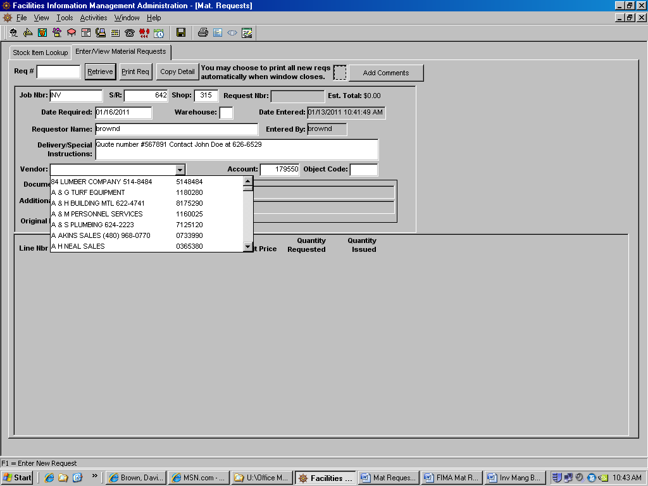

Account: and Object Code: Leave blank or as is.
Next add the items required for this request. Right click in the grayed area on the bottom of the screen.
This following box appears, click on Add and the following screen appears.
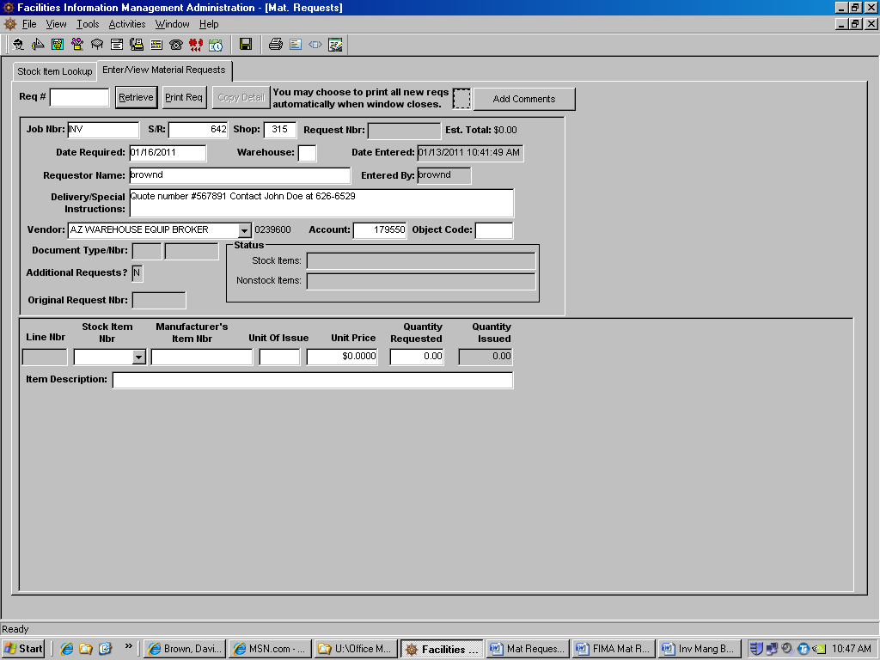
Enter the following information in the respective blocks.
Stock Item Nbr: Leave this block blank.
Manufacturer’s Item Nbr: Enter the manufacturer’s part number or model number in this block, if known.
Unit of Issue: Enter the unit of issue. Do not use punctuation marks in this field. If the unit of issue is not listed below, use EACH (See chart below)
Unit Price: Enter the price here if known, if not enter an estimated price.
Quantity Requested: Enter the quantity requested.
Item Description: Enter as much information as will fill this block. Any and all information will make the purchasing process that much faster.
Continue to add as many items as are required for this material request.
Once all items are enter into the material request click on the save button.
The material request number is now assigned to this order. At this time the material request can be printed. To print, click on the Print Req button.
Material request number
Print Req Button

Top of the Document
SPECIAL PURCHASING REQUIREMENTS AND RULES TO FOLLOW.
- All orders, non-stock and stock that exceed $300.00, requires the approval by appointed individuals within your respective shops.
- All orders that exceed $2,000.00, requires the approval of the FM Director. All approvals must be entered into the “Comments Field” of the material request in FIMA
- Orders that exceed $5,000.00 require three quotes or a Sole Source Letter. The three quotes need to be forwarded to Material Control as soon as the material request is entered into FIMA.
- Remember, a sole source letter must explain why the chosen vendor is the only vendor that can provide the required material.
- Orders that exceed $5,000.00 CAN NOT be split into numerous orders because this is considered Pyramiding and can result in the loss of PCard privileges’.
- Orders that exceed $50,000.00 require a sealed bid to be processed by the Purchasing Department.
- Any and all questions regarding material requests can always be directed to the Material Manager, supervisor or the Material Control Buyers
That completes’ this training package.

Top of the Document
Unit of Issue Table

Abbreviation | Description
BD | Bundle
BF | Board Foot
BG | Bag
BK | Book
BL | Barrel
BT | Bottle
BX | Box
CA | Cartridge
CD | Cubic Yard
CE | Cone
CF | Cubic Foot
CN | Can
CO | Container
CY | Cylinder
DR | Drum
DZ | Dozen
EA | Each
FT | Foot
GL | Gallon
GR | Gross
HD | Hundred
IN | Inch
KT | Kit
LB | Pound
MR | Meter
MX | Thousand
OZ | Ounce
PD | Pad
PG | Package
PR | Pair
PT | Pint
QT | Quart
RM | Ream
RO | Roll
SD | Skid
SE | Set
SF | Square Foot
SH | Sheet
SY | Square Yard
TN | Ton
TU | Tube
YD | Yard

Top of the Document

